**NAME: SINDIRI NITIN KUMAR**

**REG NO: RA2011028010063**

AIM: Install and Learn using AWS CLI

**Installing AWS CLI**

Download AWS CLI from the link highlighted below as shown

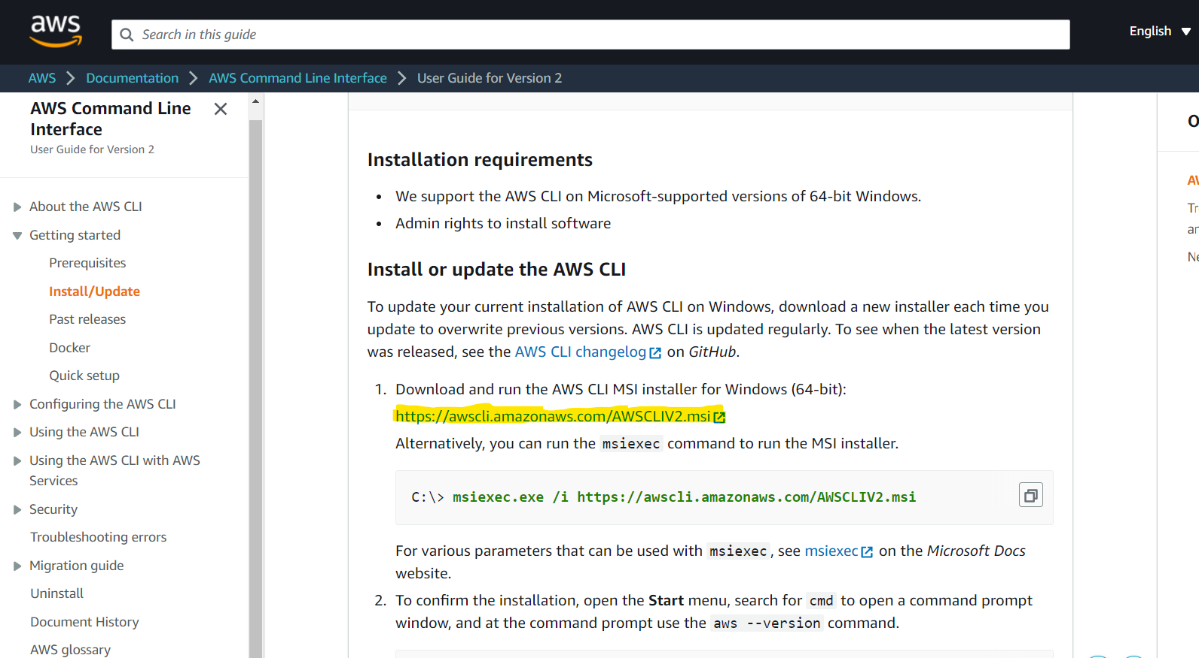

**Install AWS CLI in PC**

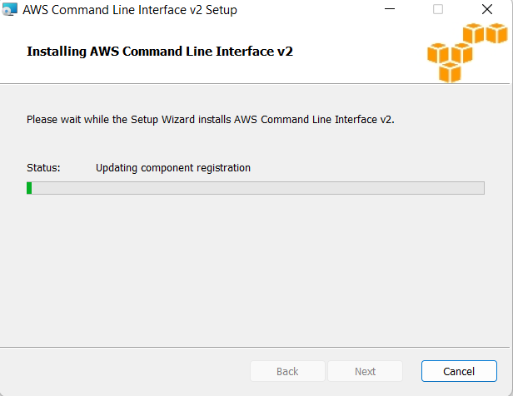

**1. AWS - -version**

This helps us login into AWS CLI which is a command line interpreter by which we can execute some AWS CLI commands. And here is **aws - -version** which helps us to install AWS CLI into command prompt or powershell in windows.

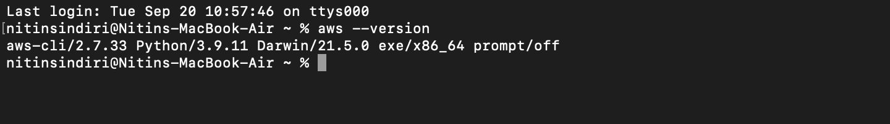

**2.aws configure**

**aws configure** helps to login into our IAM user from Root user.

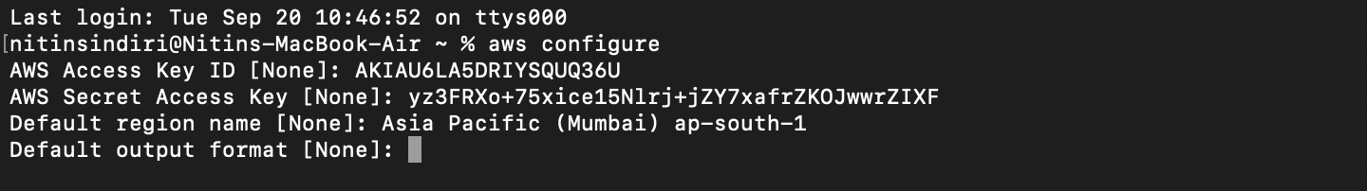

3.. Aws help

The built-in AWS CLI help command. You can get help with any command when using the AWS Command Line Interface (AWS CLI). To do so, simply type help at the end of a command name. For example, the following command displays help for the general AWS CLI options and the available top-level commands.

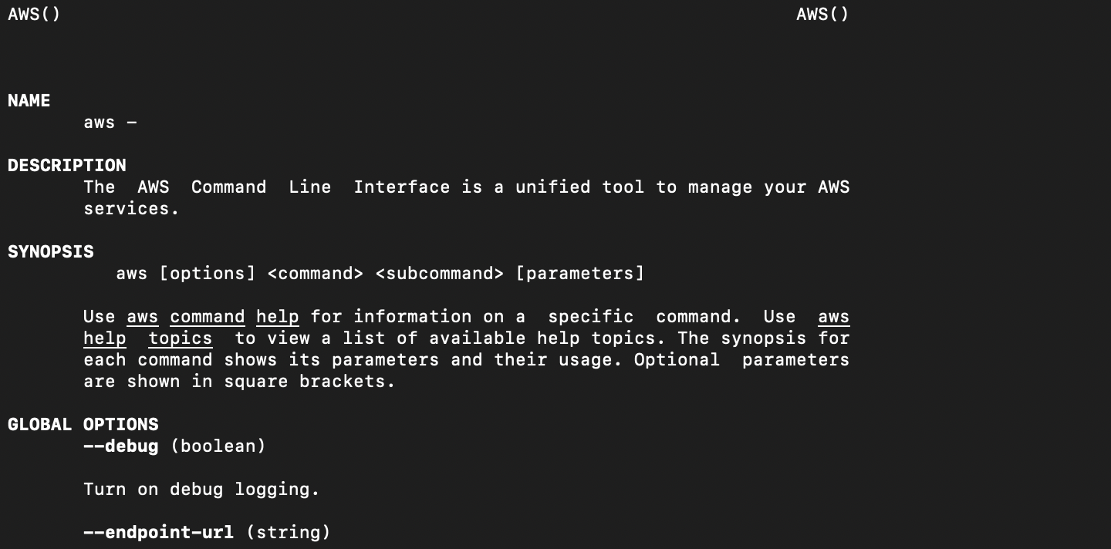

**4. sts get-caller-identity**

To get your account id using AWS CLI, run the sts get-caller-identity command, setting the --query parameter to Account to filter the output. Copied! The get-caller-identity command returns the User Id, Account Id, and the ARN of the caller

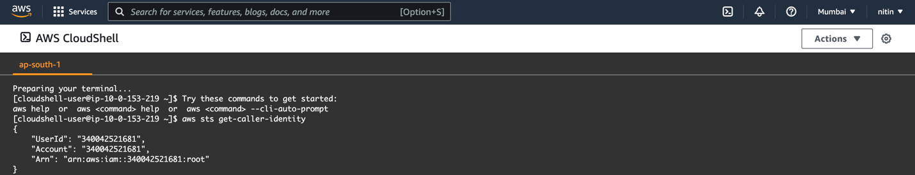

5. **aws S3 ls**

To list your buckets, folders, or objects, use the s3 ls command. Using the command without a target or options lists all buckets.

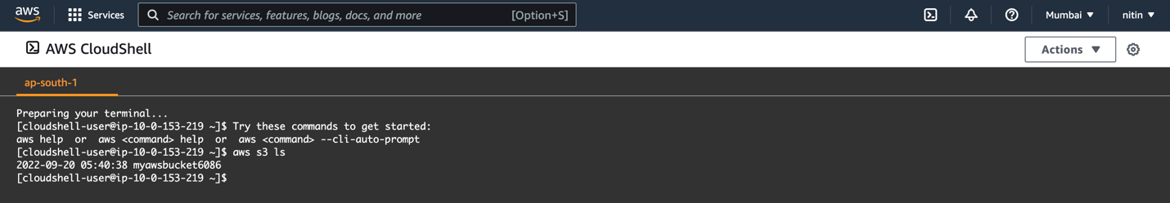

6.**aws s3 ls bucketName**

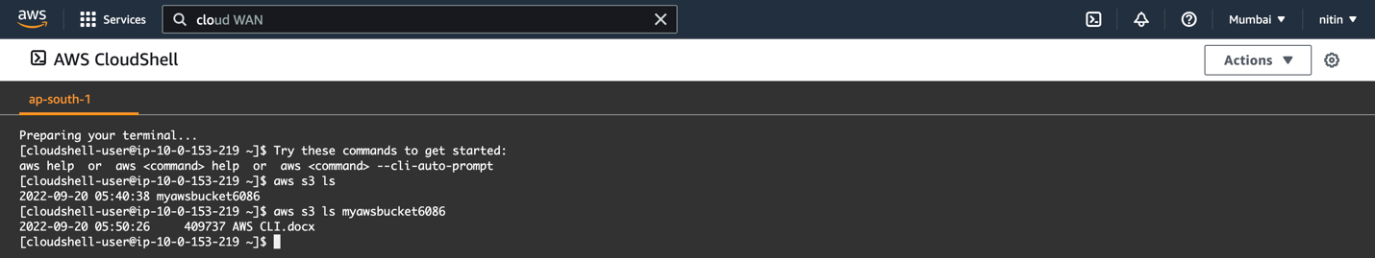

**7. aws iam list users**

To list the users present in an account, use the command to get information regarding them. It will show the list of users along with their name and id.

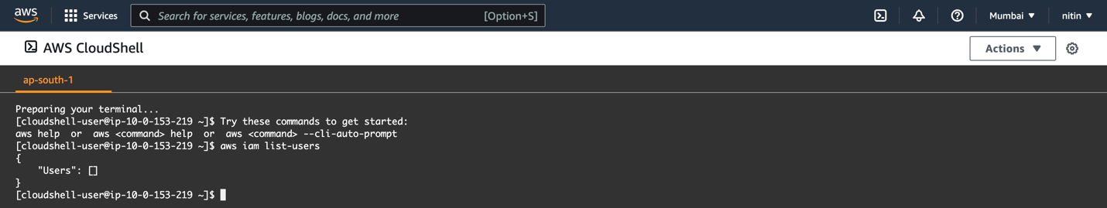

**8] aws iam list-policies**

To list the policies of aws, this command is used to get the policies present in the aws account and this is used to give permissions to the newly created users.

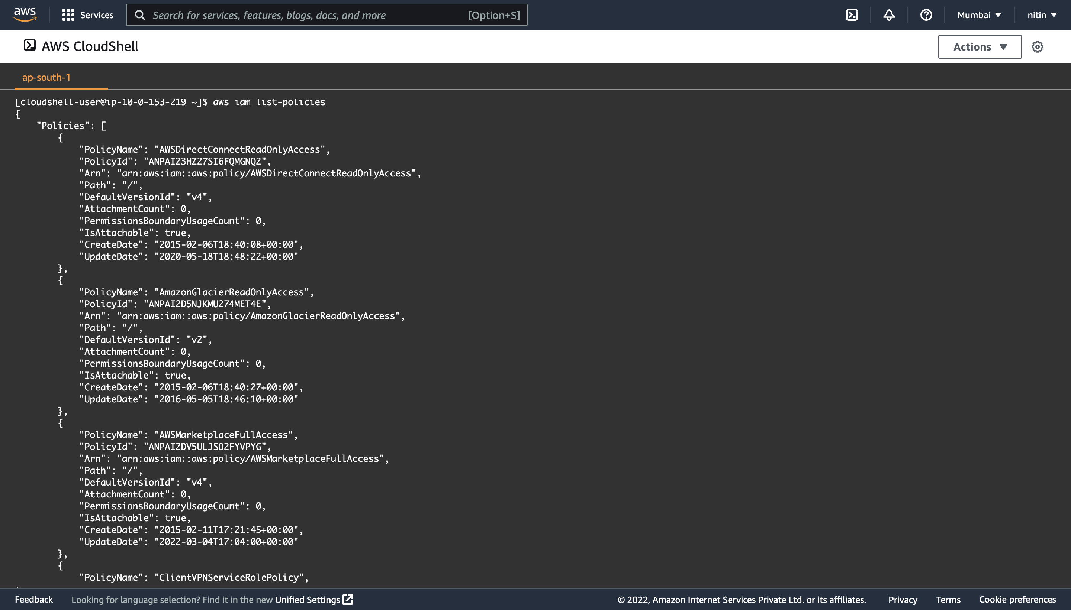

**9] delete bucket**

If your bucket does not have versioning enabled, you can use the rb (remove bucket) AWS CLI command with the --force parameter to delete the bucket and all the objects in it. This command deletes all objects first and then deletes the bucket.

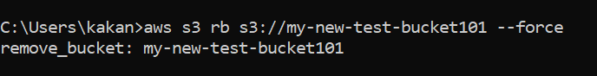

**10] remove file from bucket**

To delete objects in a bucket or your local directory, use the s3 rm command. For a few common options to use with this command, and examples, see Frequently used options for s3 commands. For a complete list of options, see s3 rm in the AWS CLI Command Reference. The following example deletes filename

